Frequencies

Notes
Output Created |  | 15-OCT-2022 17:58:10
Comments
Input | Data | C:\Users\brenda\Desktop\accademic writting practice\Jeremiah data.sav
Input | Active Dataset | DataSet1
Input | Filter | <none>
Input | Weight | <none>
Input | Split File | <none>
Input | N of Rows in Working Data File | 10
Missing Value Handling | Definition of Missing | User-defined missing values are treated as missing.
Missing Value Handling | Cases Used | Statistics are based on all cases with valid data.
Syntax |  | FREQUENCIES VARIABLES=Gender Age Occupation Relatioship Region  /BARCHART FREQ  /ORDER=ANALYSIS.
Resources | Processor Time | 00:00:02.50
Resources | Elapsed Time | 00:00:02.04

Statistics
 |  | Gender | Age in years | occupation | relatioship to contributor/ Claimant | Customer location
N | Valid | 10 | 10 | 10 | 10 | 10
N | Missing | 0 | 0 | 0 | 0 | 0

Frequency Table

Gender
 |  | Frequency | Percent | Valid Percent | Cumulative Percent
Valid | MALE | 5 | 50.0 | 50.0 | 50.0
Valid | FEMALE | 5 | 50.0 | 50.0 | 100.0
Valid | Total | 10 | 100.0 | 100.0

Age in years
 |  | Frequency | Percent | Valid Percent | Cumulative Percent
Valid | 18-24 | 2 | 20.0 | 20.0 | 20.0
Valid | 25-34 | 5 | 50.0 | 50.0 | 70.0
Valid | 35-44 | 1 | 10.0 | 10.0 | 80.0
Valid | 45-54 | 2 | 20.0 | 20.0 | 100.0
Valid | Total | 10 | 100.0 | 100.0

occupation
 |  | Frequency | Percent | Valid Percent | Cumulative Percent
Valid | Employed | 3 | 30.0 | 30.0 | 30.0
Valid | Self employed | 5 | 50.0 | 50.0 | 80.0
Valid | claimant | 2 | 20.0 | 20.0 | 100.0
Valid | Total | 10 | 100.0 | 100.0

relatioship to contributor/ Claimant
 |  | Frequency | Percent | Valid Percent | Cumulative Percent
Valid | self | 4 | 40.0 | 40.0 | 40.0
Valid | family member | 3 | 30.0 | 30.0 | 70.0
Valid | friend | 3 | 30.0 | 30.0 | 100.0
Valid | Total | 10 | 100.0 | 100.0

Customer location
 |  | Frequency | Percent | Valid Percent | Cumulative Percent
Valid | Nairobi | 4 | 40.0 | 40.0 | 40.0
Valid | Rift Valley | 2 | 20.0 | 20.0 | 60.0
Valid | Central/Eastern | 2 | 20.0 | 20.0 | 80.0
Valid | Nyanza/Western | 2 | 20.0 | 20.0 | 100.0
Valid | Total | 10 | 100.0 | 100.0

Bar Chart

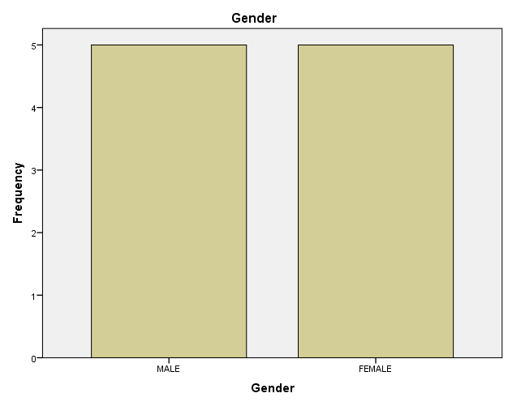

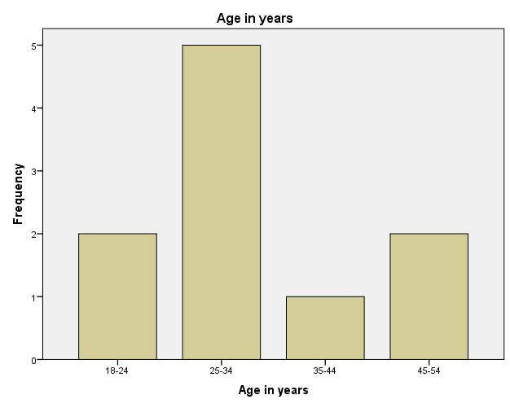

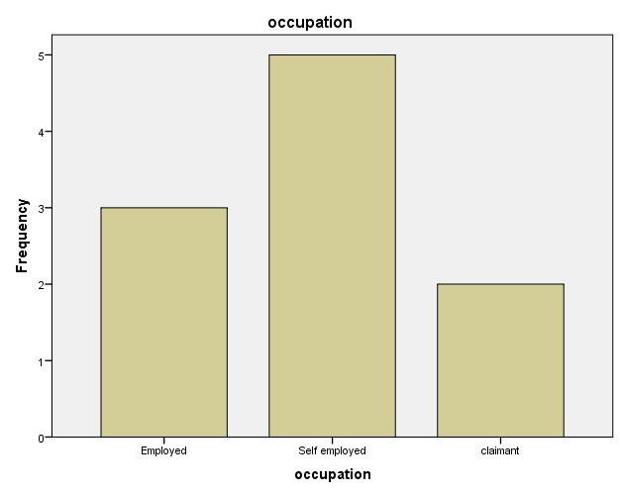

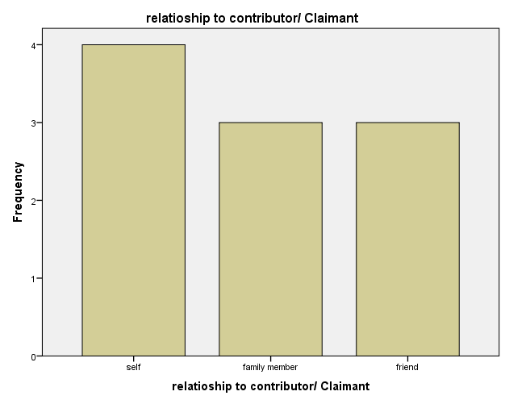

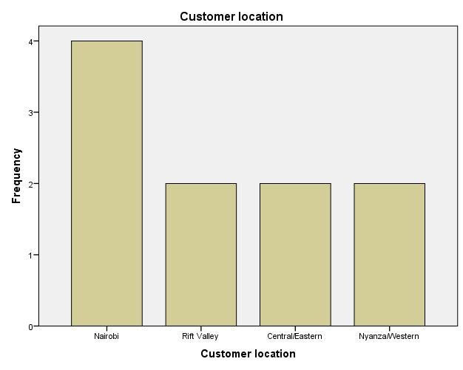

Frequencies

Notes
Output Created |  | 15-OCT-2022 18:07:10
Comments
Input | Data | C:\Users\brenda\Desktop\accademic writting practice\Jeremiah data.sav
Input | Active Dataset | DataSet1
Input | Filter | <none>
Input | Weight | <none>
Input | Split File | <none>
Input | N of Rows in Working Data File | 10
Missing Value Handling | Definition of Missing | User-defined missing values are treated as missing.
Missing Value Handling | Cases Used | Statistics are based on all cases with valid data.

Notes
Syntax |  | FREQUENCIES VARIABLES=Radio TV Newspaper Friends Publicity_boards Employer Visiting_premises Others Retirement_Benefit Survival_benefit Invalidity_benefit Funeral_grant Emigration_benefit Withdrawal_benefit Offices_distribution Regisration_process  Contribution_modes Contribution_affordability Saficient_income_contribution contributions_safety investments_using_contributions NSSF_benefit Rules Corruption_activities Better_delivery_services Resposible_operations Team_work  /BARCHART FREQ  /ORDER=ANALYSIS.
Resources | Processor Time | 00:00:04.56
Resources | Elapsed Time | 00:00:04.44

Statistics
 |  | Did you ear abt NSSF on Randio? | Did you ear abt NSSF on TV? | Did you ear abt NSSF on Newspaper? | Did you ear abt NSSF on Friends/relatives/colligues? | Did you ear abt NSSF on publicity boards?
N | Valid | 10 | 10 | 10 | 10 | 10
N | Missing | 0 | 0 | 0 | 0 | 0

Statistics
 |  | Did you ear abt NSSF through employer? | Did you ear abt NSSF by visiting premises? | Did you ear abt NSSF by other means? | retirement benefit | Survival benefit
N | Valid | 10 | 10 | 10 | 10 | 10
N | Missing | 0 | 0 | 0 | 0 | 0

Statistics
 |  | Invalidity benefit | Funeral benefit | Emigration benefit | Withdrawal benefit | satisfaction level by distribution of NSSF offices in the country
N | Valid | 10 | 10 | 10 | 10 | 10
N | Missing | 0 | 0 | 0 | 0 | 0

Statistics
 |  | satisfaction level by registration process | satisfaction level by modes of contribution to NSSF | the affordability of contribution to NSSF (within your budget) | the contibution i make shall enable sufficient income in the end | the safety of contributions made to NSSF
N | Valid | 10 | 10 | 10 | 10 | 10
N | Missing | 0 | 0 | 0 | 0 | 0

Statistics
 |  | investiments made by NSSF using our contributions | NSSF's benefit compared to competitors' benefit | Decisions and rules exercised by NSSF staff | NSSF does not tolerate currupt activities | NSSF staff came up with new or better weays of delivering servises
N | Valid | 10 | 10 | 10 | 10 | 10
N | Missing | 0 | 0 | 0 | 0 | 0

Statistics
 |  | NSSF staff act responsibly and openly in their day-to-day work | NSSF staff work together when necessary to meet my needs
N | Valid | 10 | 10
N | Missing | 0 | 0

Frequency Table

Did you ear abt NSSF on Randio?
 |  | Frequency | Percent | Valid Percent | Cumulative Percent
Valid | YES | 8 | 80.0 | 80.0 | 80.0
Valid | NO | 2 | 20.0 | 20.0 | 100.0
Valid | Total | 10 | 100.0 | 100.0

Did you ear abt NSSF on TV?
 |  | Frequency | Percent | Valid Percent | Cumulative Percent
Valid | YES | 7 | 70.0 | 70.0 | 70.0
Valid | NO | 3 | 30.0 | 30.0 | 100.0
Valid | Total | 10 | 100.0 | 100.0

Did you ear abt NSSF on Newspaper?
 |  | Frequency | Percent | Valid Percent | Cumulative Percent
Valid | YES | 5 | 50.0 | 50.0 | 50.0
Valid | NO | 5 | 50.0 | 50.0 | 100.0
Valid | Total | 10 | 100.0 | 100.0

Did you ear abt NSSF on Friends/relatives/colligues?
 |  | Frequency | Percent | Valid Percent | Cumulative Percent
Valid | YES | 5 | 50.0 | 50.0 | 50.0
Valid | NO | 5 | 50.0 | 50.0 | 100.0
Valid | Total | 10 | 100.0 | 100.0

Did you ear abt NSSF on publicity boards?
 |  | Frequency | Percent | Valid Percent | Cumulative Percent
Valid | YES | 4 | 40.0 | 40.0 | 40.0
Valid | NO | 6 | 60.0 | 60.0 | 100.0
Valid | Total | 10 | 100.0 | 100.0

Did you ear abt NSSF through employer?
 |  | Frequency | Percent | Valid Percent | Cumulative Percent
Valid | YES | 5 | 50.0 | 50.0 | 50.0
Valid | NO | 5 | 50.0 | 50.0 | 100.0
Valid | Total | 10 | 100.0 | 100.0

Did you ear abt NSSF by visiting premises?
 |  | Frequency | Percent | Valid Percent | Cumulative Percent
Valid | YES | 10 | 100.0 | 100.0 | 100.0

Did you ear abt NSSF by other means?
 |  | Frequency | Percent | Valid Percent | Cumulative Percent
Valid | YES | 7 | 70.0 | 70.0 | 70.0
Valid | NO | 3 | 30.0 | 30.0 | 100.0
Valid | Total | 10 | 100.0 | 100.0

retirement benefit
 |  | Frequency | Percent | Valid Percent | Cumulative Percent
Valid | YES | 10 | 100.0 | 100.0 | 100.0

Survival benefit
 |  | Frequency | Percent | Valid Percent | Cumulative Percent
Valid | YES | 7 | 70.0 | 70.0 | 70.0
Valid | NO | 3 | 30.0 | 30.0 | 100.0
Valid | Total | 10 | 100.0 | 100.0

Invalidity benefit
 |  | Frequency | Percent | Valid Percent | Cumulative Percent
Valid | YES | 7 | 70.0 | 70.0 | 70.0
Valid | NO | 3 | 30.0 | 30.0 | 100.0
Valid | Total | 10 | 100.0 | 100.0

Funeral benefit
 |  | Frequency | Percent | Valid Percent | Cumulative Percent
Valid | YES | 7 | 70.0 | 70.0 | 70.0
Valid | NO | 3 | 30.0 | 30.0 | 100.0
Valid | Total | 10 | 100.0 | 100.0

Emigration benefit
 |  | Frequency | Percent | Valid Percent | Cumulative Percent
Valid | YES | 6 | 60.0 | 60.0 | 60.0
Valid | NO | 4 | 40.0 | 40.0 | 100.0
Valid | Total | 10 | 100.0 | 100.0

Withdrawal benefit
 |  | Frequency | Percent | Valid Percent | Cumulative Percent
Valid | YES | 1 | 10.0 | 10.0 | 10.0
Valid | NO | 9 | 90.0 | 90.0 | 100.0
Valid | Total | 10 | 100.0 | 100.0

satisfaction level by distribution of NSSF offices in the country
 |  | Frequency | Percent | Valid Percent | Cumulative Percent
Valid | Satisfied | 4 | 40.0 | 40.0 | 40.0
Valid | Very satisfied | 6 | 60.0 | 60.0 | 100.0
Valid | Total | 10 | 100.0 | 100.0

satisfaction level by registration process
 |  | Frequency | Percent | Valid Percent | Cumulative Percent
Valid | neutral | 2 | 20.0 | 20.0 | 20.0
Valid | satisfied | 8 | 80.0 | 80.0 | 100.0
Valid | Total | 10 | 100.0 | 100.0

satisfaction level by modes of contribution to NSSF
 |  | Frequency | Percent | Valid Percent | Cumulative Percent
Valid | neutral | 1 | 10.0 | 10.0 | 10.0
Valid | satisfied | 9 | 90.0 | 90.0 | 100.0
Valid | Total | 10 | 100.0 | 100.0

the affordability of contribution to NSSF (within your budget)
 |  | Frequency | Percent | Valid Percent | Cumulative Percent
Valid | disatisfied | 2 | 20.0 | 20.0 | 20.0
Valid | neutral | 3 | 30.0 | 30.0 | 50.0
Valid | satisfied | 4 | 40.0 | 40.0 | 90.0
Valid | don't know/ not applicable | 1 | 10.0 | 10.0 | 100.0
Valid | Total | 10 | 100.0 | 100.0

the contibution i make shall enable sufficient income in the end
 |  | Frequency | Percent | Valid Percent | Cumulative Percent
Valid | neutral | 5 | 50.0 | 50.0 | 50.0
Valid | satisfied | 5 | 50.0 | 50.0 | 100.0
Valid | Total | 10 | 100.0 | 100.0

the safety of contributions made to NSSF
 |  | Frequency | Percent | Valid Percent | Cumulative Percent
Valid | disatisfied | 1 | 10.0 | 10.0 | 10.0
Valid | neutral | 5 | 50.0 | 50.0 | 60.0
Valid | satisfied | 4 | 40.0 | 40.0 | 100.0
Valid | Total | 10 | 100.0 | 100.0

investiments made by NSSF using our contributions
 |  | Frequency | Percent | Valid Percent | Cumulative Percent
Valid | neutral | 3 | 30.0 | 30.0 | 30.0
Valid | satisfied | 7 | 70.0 | 70.0 | 100.0
Valid | Total | 10 | 100.0 | 100.0

NSSF's benefit compared to competitors' benefit
 |  | Frequency | Percent | Valid Percent | Cumulative Percent
Valid | disatisfied | 1 | 10.0 | 10.0 | 10.0
Valid | neutral | 1 | 10.0 | 10.0 | 20.0
Valid | satisfied | 8 | 80.0 | 80.0 | 100.0
Valid | Total | 10 | 100.0 | 100.0

Decisions and rules exercised by NSSF staff
 |  | Frequency | Percent | Valid Percent | Cumulative Percent
Valid | neutral | 1 | 10.0 | 10.0 | 10.0
Valid | satisfied | 5 | 50.0 | 50.0 | 60.0
Valid | very satisfied | 4 | 40.0 | 40.0 | 100.0
Valid | Total | 10 | 100.0 | 100.0

NSSF does not tolerate currupt activities
 |  | Frequency | Percent | Valid Percent | Cumulative Percent
Valid | Disagree | 1 | 10.0 | 10.0 | 10.0
Valid | Neither agree or dissagree | 1 | 10.0 | 10.0 | 20.0
Valid | agree | 5 | 50.0 | 50.0 | 70.0
Valid | Strongly agree | 3 | 30.0 | 30.0 | 100.0
Valid | Total | 10 | 100.0 | 100.0

NSSF staff came up with new or better weays of delivering servises
 |  | Frequency | Percent | Valid Percent | Cumulative Percent
Valid | agree | 10 | 100.0 | 100.0 | 100.0

NSSF staff act responsibly and openly in their day-to-day work
 |  | Frequency | Percent | Valid Percent | Cumulative Percent
Valid | Agree | 10 | 100.0 | 100.0 | 100.0

NSSF staff work together when necessary to meet my needs
 |  | Frequency | Percent | Valid Percent | Cumulative Percent
Valid | agree | 9 | 90.0 | 90.0 | 90.0
Valid | strongly agree | 1 | 10.0 | 10.0 | 100.0
Valid | Total | 10 | 100.0 | 100.0

Bar Chart

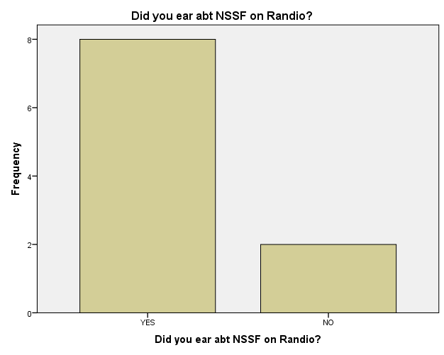

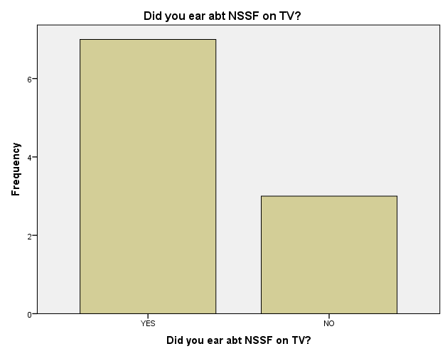

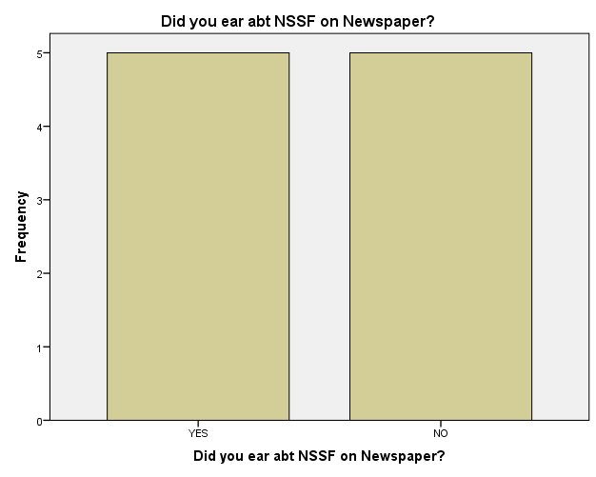

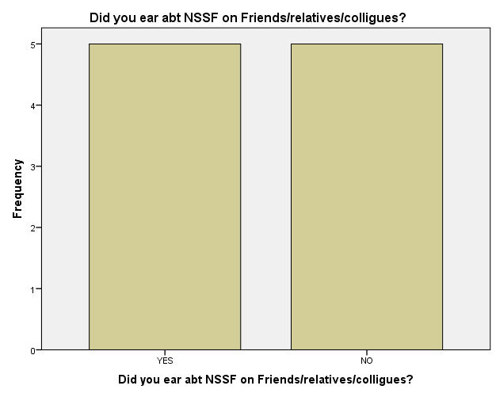

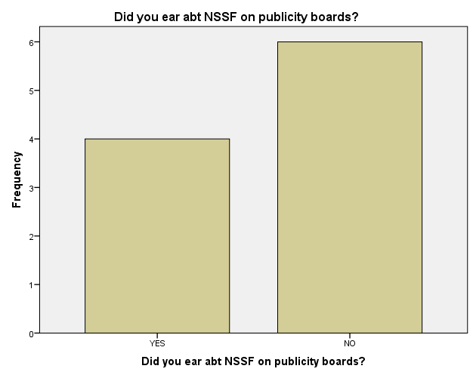

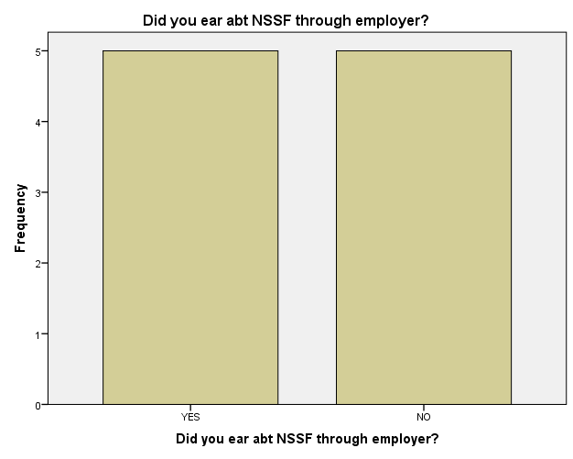

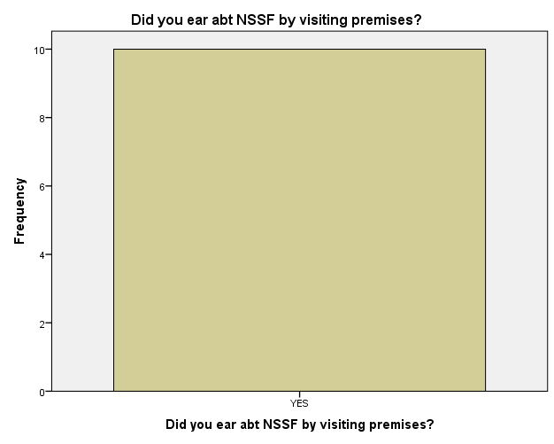

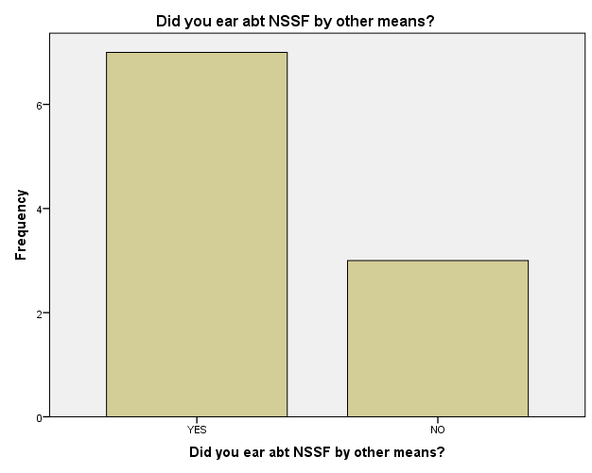

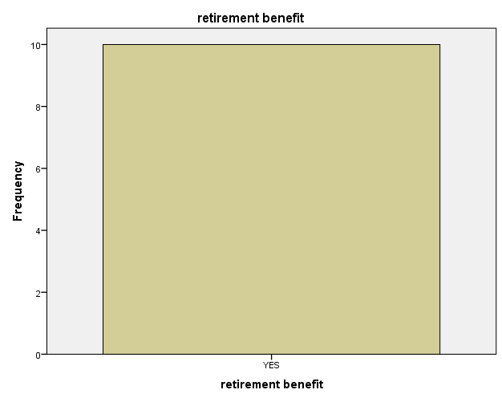

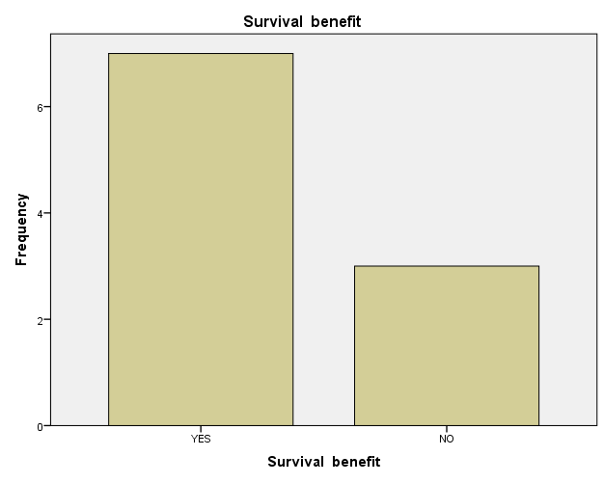

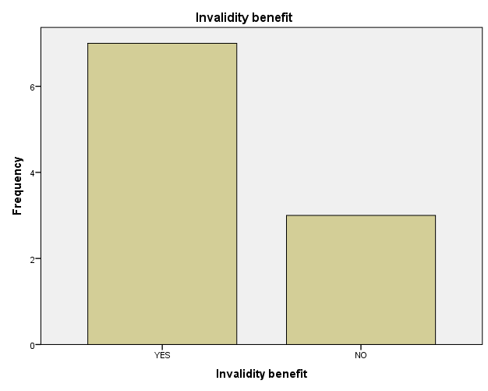

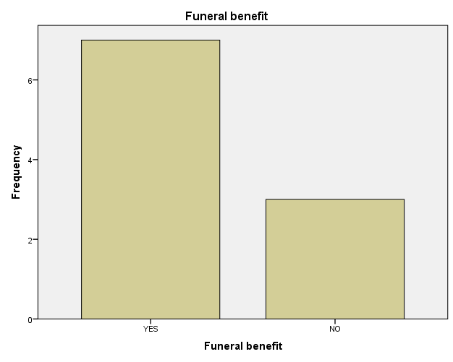

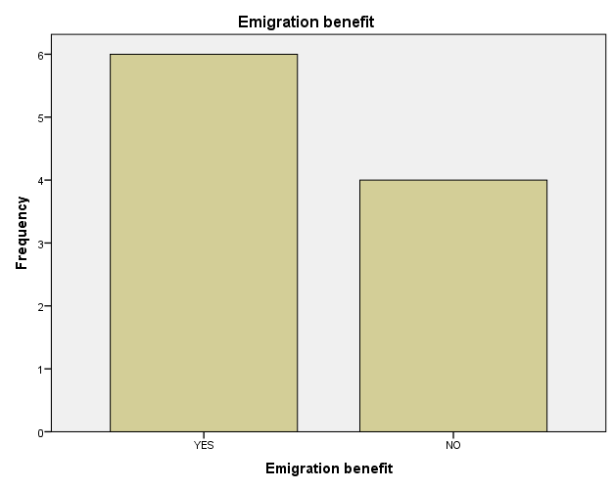

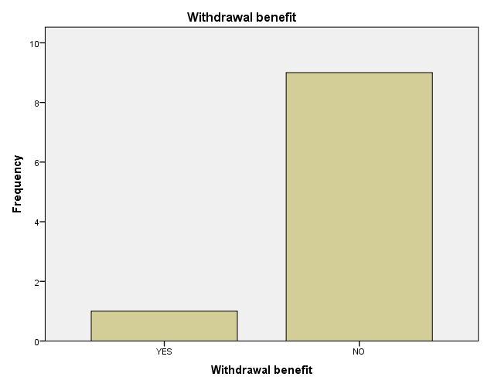

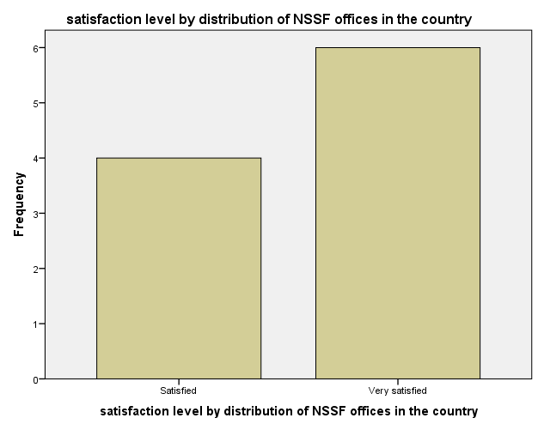

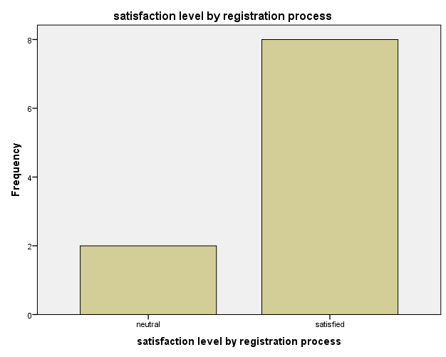

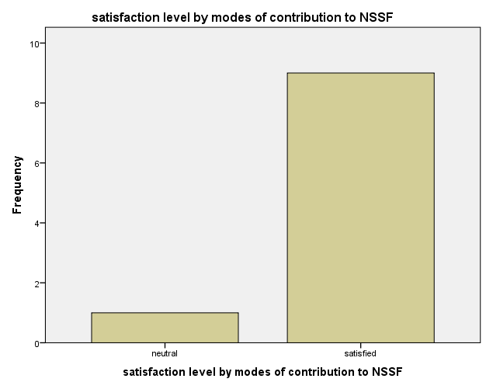

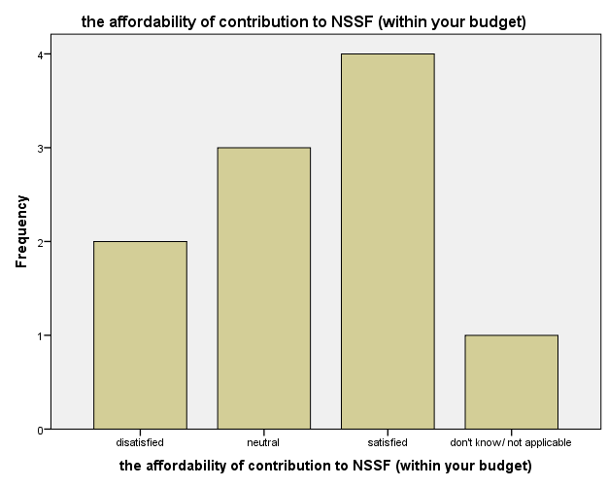

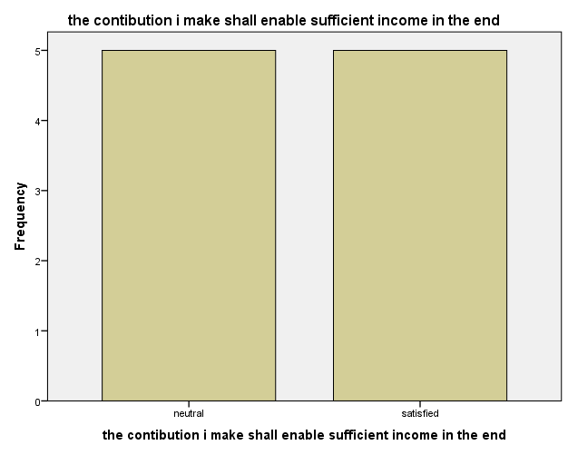

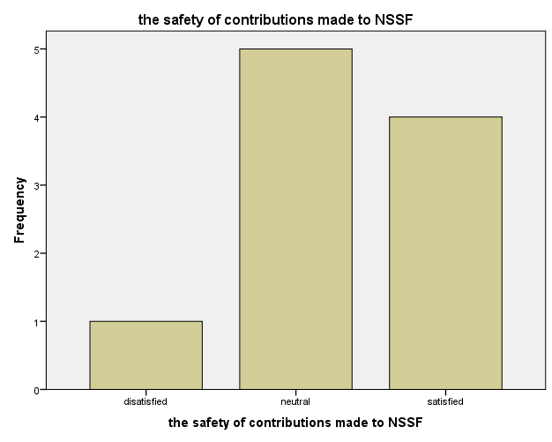

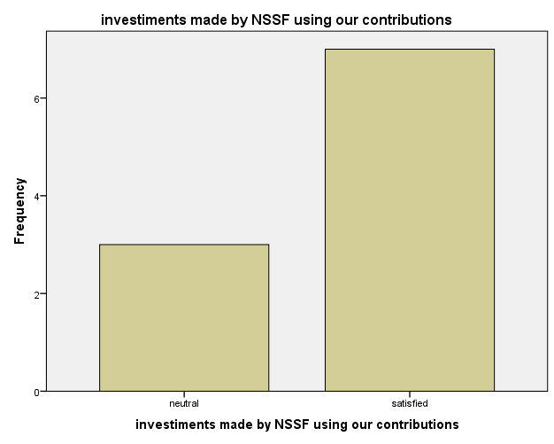

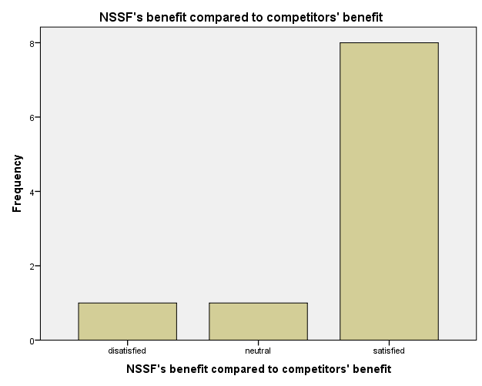

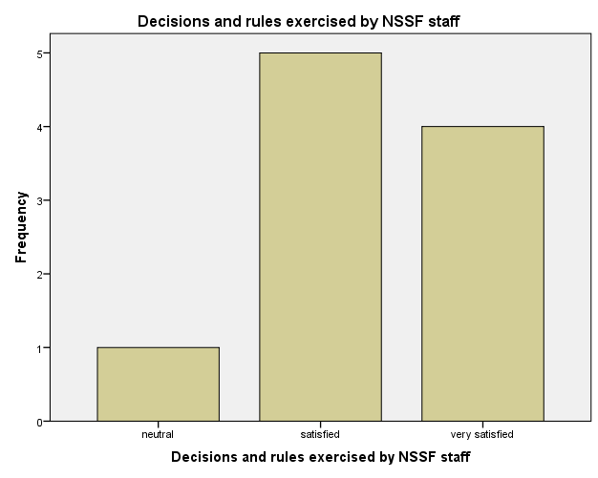

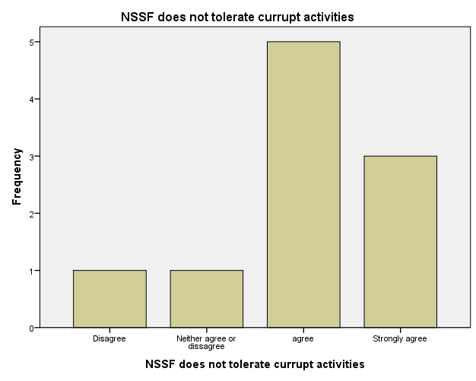

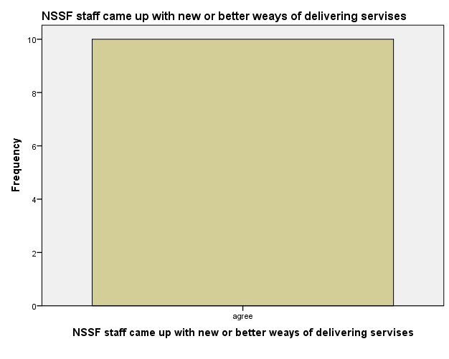

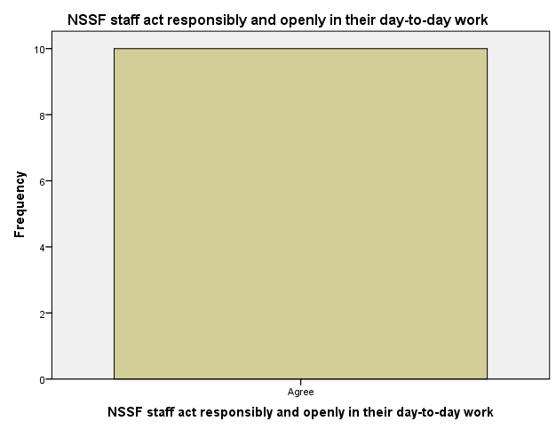

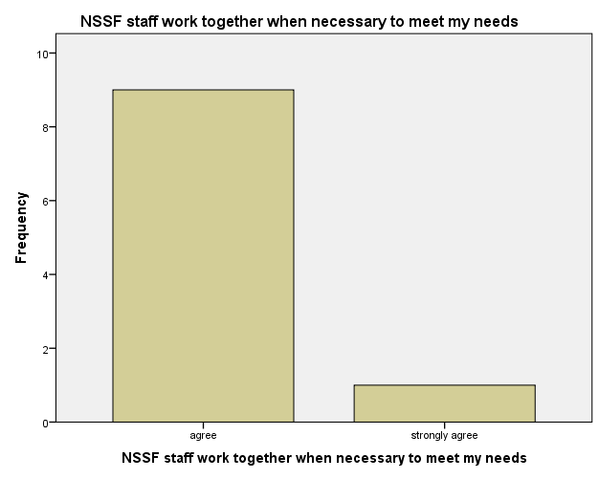

Frequencies

Notes
Output Created |  | 15-OCT-2022 18:12:18
Comments
Input | Data | C:\Users\brenda\Desktop\accademic writting practice\Jeremiah data.sav
Input | Active Dataset | DataSet1
Input | Filter | <none>
Input | Weight | <none>
Input | Split File | <none>
Input | N of Rows in Working Data File | 10
Missing Value Handling | Definition of Missing | User-defined missing values are treated as missing.
Missing Value Handling | Cases Used | Statistics are based on all cases with valid data.

Notes
Syntax |  | FREQUENCIES VARIABLES=Gender Age Occupation Relatioship Region Radio TV Newspaper Friends Publicity_boards Employer Visiting_premises Others Retirement_Benefit Survival_benefit Invalidity_benefit Funeral_grant Emigration_benefit Withdrawal_benefit  Offices_distribution Regisration_process Contribution_modes Contribution_affordability Saficient_income_contribution contributions_safety investments_using_contributions NSSF_benefit Rules Corruption_activities Better_delivery_services  Resposible_operations Team_work  /BARCHART FREQ  /ORDER=ANALYSIS.
Resources | Processor Time | 00:00:04.52
Resources | Elapsed Time | 00:00:04.34

Statistics
 |  | Gender | Age in years | occupation | relatioship to contributor/ Claimant | Customer location
N | Valid | 10 | 10 | 10 | 10 | 10
N | Missing | 0 | 0 | 0 | 0 | 0

Statistics
 |  | Did you ear abt NSSF on Randio? | Did you ear abt NSSF on TV? | Did you ear abt NSSF on Newspaper? | Did you ear abt NSSF on Friends/relatives/colligues? | Did you ear abt NSSF on publicity boards?
N | Valid | 10 | 10 | 10 | 10 | 10
N | Missing | 0 | 0 | 0 | 0 | 0

Statistics
 |  | Did you ear abt NSSF through employer? | Did you ear abt NSSF by visiting premises? | Did you ear abt NSSF by other means? | retirement benefit | Survival benefit
N | Valid | 10 | 10 | 10 | 10 | 10
N | Missing | 0 | 0 | 0 | 0 | 0

Statistics
 |  | Invalidity benefit | Funeral benefit | Emigration benefit | Withdrawal benefit | satisfaction level by distribution of NSSF offices in the country
N | Valid | 10 | 10 | 10 | 10 | 10
N | Missing | 0 | 0 | 0 | 0 | 0

Statistics
 |  | satisfaction level by registration process | satisfaction level by modes of contribution to NSSF | the affordability of contribution to NSSF (within your budget) | the contibution i make shall enable sufficient income in the end | the safety of contributions made to NSSF
N | Valid | 10 | 10 | 10 | 10 | 10
N | Missing | 0 | 0 | 0 | 0 | 0

Statistics
 |  | investiments made by NSSF using our contributions | NSSF's benefit compared to competitors' benefit | Decisions and rules exercised by NSSF staff | NSSF does not tolerate currupt activities | NSSF staff came up with new or better weays of delivering servises
N | Valid | 10 | 10 | 10 | 10 | 10
N | Missing | 0 | 0 | 0 | 0 | 0

Statistics
 |  | NSSF staff act responsibly and openly in their day-to-day work | NSSF staff work together when necessary to meet my needs
N | Valid | 10 | 10
N | Missing | 0 | 0

Frequency Table

Gender
 |  | Frequency | Percent | Valid Percent | Cumulative Percent
Valid | MALE | 5 | 50.0 | 50.0 | 50.0
Valid | FEMALE | 5 | 50.0 | 50.0 | 100.0
Valid | Total | 10 | 100.0 | 100.0

Age in years
 |  | Frequency | Percent | Valid Percent | Cumulative Percent
Valid | 18-24 | 2 | 20.0 | 20.0 | 20.0
Valid | 25-34 | 5 | 50.0 | 50.0 | 70.0
Valid | 35-44 | 1 | 10.0 | 10.0 | 80.0
Valid | 45-54 | 2 | 20.0 | 20.0 | 100.0
Valid | Total | 10 | 100.0 | 100.0

occupation
 |  | Frequency | Percent | Valid Percent | Cumulative Percent
Valid | Employed | 3 | 30.0 | 30.0 | 30.0
Valid | Self employed | 5 | 50.0 | 50.0 | 80.0
Valid | claimant | 2 | 20.0 | 20.0 | 100.0
Valid | Total | 10 | 100.0 | 100.0

relatioship to contributor/ Claimant
 |  | Frequency | Percent | Valid Percent | Cumulative Percent
Valid | self | 4 | 40.0 | 40.0 | 40.0
Valid | family member | 3 | 30.0 | 30.0 | 70.0
Valid | friend | 3 | 30.0 | 30.0 | 100.0
Valid | Total | 10 | 100.0 | 100.0

Customer location
 |  | Frequency | Percent | Valid Percent | Cumulative Percent
Valid | Nairobi | 4 | 40.0 | 40.0 | 40.0
Valid | Rift Valley | 2 | 20.0 | 20.0 | 60.0
Valid | Central/Eastern | 2 | 20.0 | 20.0 | 80.0
Valid | Nyanza/Western | 2 | 20.0 | 20.0 | 100.0
Valid | Total | 10 | 100.0 | 100.0

Did you ear abt NSSF on Randio?
 |  | Frequency | Percent | Valid Percent | Cumulative Percent
Valid | YES | 8 | 80.0 | 80.0 | 80.0
Valid | NO | 2 | 20.0 | 20.0 | 100.0
Valid | Total | 10 | 100.0 | 100.0

Did you ear abt NSSF on TV?
 |  | Frequency | Percent | Valid Percent | Cumulative Percent
Valid | YES | 7 | 70.0 | 70.0 | 70.0
Valid | NO | 3 | 30.0 | 30.0 | 100.0
Valid | Total | 10 | 100.0 | 100.0

Did you ear abt NSSF on Newspaper?
 |  | Frequency | Percent | Valid Percent | Cumulative Percent
Valid | YES | 5 | 50.0 | 50.0 | 50.0
Valid | NO | 5 | 50.0 | 50.0 | 100.0
Valid | Total | 10 | 100.0 | 100.0

Did you ear abt NSSF on Friends/relatives/colligues?
 |  | Frequency | Percent | Valid Percent | Cumulative Percent
Valid | YES | 5 | 50.0 | 50.0 | 50.0
Valid | NO | 5 | 50.0 | 50.0 | 100.0
Valid | Total | 10 | 100.0 | 100.0

Did you ear abt NSSF on publicity boards?
 |  | Frequency | Percent | Valid Percent | Cumulative Percent
Valid | YES | 4 | 40.0 | 40.0 | 40.0
Valid | NO | 6 | 60.0 | 60.0 | 100.0
Valid | Total | 10 | 100.0 | 100.0

Did you ear abt NSSF through employer?
 |  | Frequency | Percent | Valid Percent | Cumulative Percent
Valid | YES | 5 | 50.0 | 50.0 | 50.0
Valid | NO | 5 | 50.0 | 50.0 | 100.0
Valid | Total | 10 | 100.0 | 100.0

Did you ear abt NSSF by visiting premises?
 |  | Frequency | Percent | Valid Percent | Cumulative Percent
Valid | YES | 10 | 100.0 | 100.0 | 100.0

Did you ear abt NSSF by other means?
 |  | Frequency | Percent | Valid Percent | Cumulative Percent
Valid | YES | 7 | 70.0 | 70.0 | 70.0
Valid | NO | 3 | 30.0 | 30.0 | 100.0
Valid | Total | 10 | 100.0 | 100.0

retirement benefit
 |  | Frequency | Percent | Valid Percent | Cumulative Percent
Valid | YES | 10 | 100.0 | 100.0 | 100.0

Survival benefit
 |  | Frequency | Percent | Valid Percent | Cumulative Percent
Valid | YES | 7 | 70.0 | 70.0 | 70.0
Valid | NO | 3 | 30.0 | 30.0 | 100.0
Valid | Total | 10 | 100.0 | 100.0

Invalidity benefit
 |  | Frequency | Percent | Valid Percent | Cumulative Percent
Valid | YES | 7 | 70.0 | 70.0 | 70.0
Valid | NO | 3 | 30.0 | 30.0 | 100.0
Valid | Total | 10 | 100.0 | 100.0

Funeral benefit
 |  | Frequency | Percent | Valid Percent | Cumulative Percent
Valid | YES | 7 | 70.0 | 70.0 | 70.0
Valid | NO | 3 | 30.0 | 30.0 | 100.0
Valid | Total | 10 | 100.0 | 100.0

Emigration benefit
 |  | Frequency | Percent | Valid Percent | Cumulative Percent
Valid | YES | 6 | 60.0 | 60.0 | 60.0
Valid | NO | 4 | 40.0 | 40.0 | 100.0
Valid | Total | 10 | 100.0 | 100.0

Withdrawal benefit
 |  | Frequency | Percent | Valid Percent | Cumulative Percent
Valid | YES | 1 | 10.0 | 10.0 | 10.0
Valid | NO | 9 | 90.0 | 90.0 | 100.0
Valid | Total | 10 | 100.0 | 100.0

satisfaction level by distribution of NSSF offices in the country
 |  | Frequency | Percent | Valid Percent | Cumulative Percent
Valid | Satisfied | 4 | 40.0 | 40.0 | 40.0
Valid | Very satisfied | 6 | 60.0 | 60.0 | 100.0
Valid | Total | 10 | 100.0 | 100.0

satisfaction level by registration process
 |  | Frequency | Percent | Valid Percent | Cumulative Percent
Valid | neutral | 2 | 20.0 | 20.0 | 20.0
Valid | satisfied | 8 | 80.0 | 80.0 | 100.0
Valid | Total | 10 | 100.0 | 100.0

satisfaction level by modes of contribution to NSSF
 |  | Frequency | Percent | Valid Percent | Cumulative Percent
Valid | neutral | 1 | 10.0 | 10.0 | 10.0
Valid | satisfied | 9 | 90.0 | 90.0 | 100.0
Valid | Total | 10 | 100.0 | 100.0

the affordability of contribution to NSSF (within your budget)
 |  | Frequency | Percent | Valid Percent | Cumulative Percent
Valid | disatisfied | 2 | 20.0 | 20.0 | 20.0
Valid | neutral | 3 | 30.0 | 30.0 | 50.0
Valid | satisfied | 4 | 40.0 | 40.0 | 90.0
Valid | don't know/ not applicable | 1 | 10.0 | 10.0 | 100.0
Valid | Total | 10 | 100.0 | 100.0

the contibution i make shall enable sufficient income in the end
 |  | Frequency | Percent | Valid Percent | Cumulative Percent
Valid | neutral | 5 | 50.0 | 50.0 | 50.0
Valid | satisfied | 5 | 50.0 | 50.0 | 100.0
Valid | Total | 10 | 100.0 | 100.0

the safety of contributions made to NSSF
 |  | Frequency | Percent | Valid Percent | Cumulative Percent
Valid | disatisfied | 1 | 10.0 | 10.0 | 10.0
Valid | neutral | 5 | 50.0 | 50.0 | 60.0
Valid | satisfied | 4 | 40.0 | 40.0 | 100.0
Valid | Total | 10 | 100.0 | 100.0

investiments made by NSSF using our contributions
 |  | Frequency | Percent | Valid Percent | Cumulative Percent
Valid | neutral | 3 | 30.0 | 30.0 | 30.0
Valid | satisfied | 7 | 70.0 | 70.0 | 100.0
Valid | Total | 10 | 100.0 | 100.0

NSSF's benefit compared to competitors' benefit
 |  | Frequency | Percent | Valid Percent | Cumulative Percent
Valid | disatisfied | 1 | 10.0 | 10.0 | 10.0
Valid | neutral | 1 | 10.0 | 10.0 | 20.0
Valid | satisfied | 8 | 80.0 | 80.0 | 100.0
Valid | Total | 10 | 100.0 | 100.0

Decisions and rules exercised by NSSF staff
 |  | Frequency | Percent | Valid Percent | Cumulative Percent
Valid | neutral | 1 | 10.0 | 10.0 | 10.0
Valid | satisfied | 5 | 50.0 | 50.0 | 60.0
Valid | very satisfied | 4 | 40.0 | 40.0 | 100.0
Valid | Total | 10 | 100.0 | 100.0

NSSF does not tolerate currupt activities
 |  | Frequency | Percent | Valid Percent | Cumulative Percent
Valid | Disagree | 1 | 10.0 | 10.0 | 10.0
Valid | Neither agree or dissagree | 1 | 10.0 | 10.0 | 20.0
Valid | agree | 5 | 50.0 | 50.0 | 70.0
Valid | Strongly agree | 3 | 30.0 | 30.0 | 100.0
Valid | Total | 10 | 100.0 | 100.0

NSSF staff came up with new or better weays of delivering servises
 |  | Frequency | Percent | Valid Percent | Cumulative Percent
Valid | agree | 10 | 100.0 | 100.0 | 100.0

NSSF staff act responsibly and openly in their day-to-day work
 |  | Frequency | Percent | Valid Percent | Cumulative Percent
Valid | Agree | 10 | 100.0 | 100.0 | 100.0

NSSF staff work together when necessary to meet my needs
 |  | Frequency | Percent | Valid Percent | Cumulative Percent
Valid | agree | 9 | 90.0 | 90.0 | 90.0
Valid | strongly agree | 1 | 10.0 | 10.0 | 100.0
Valid | Total | 10 | 100.0 | 100.0

Bar Chart

